 ASSIGNMENT - 5

MACHINE LEARNING

**Q1 to Q15 are subjective answer type questions, Answer them briefly.**

1. R-squared or Residual Sum of Squares (RSS) which one of these two is a better measure of goodness of fit model in regression and why?

ANSWER: R-squared and Residual Sum of Squares (RSS) are both measures of the goodness of fit of a regression model, but they serve slightly different purposes.

R-squared is a statistical measure that represents the proportion of the variance for a dependent variable that's explained by an independent variable or variables in a regression model. In other words, R-squared measures the extent to which changes in the dependent variable can be predicted by changes in the independent variable(s). Higher R-squared values indicate a better fit of the regression model to the data. Therefore, R-squared is often used to compare different models and select the best one.

On the other hand, Residual Sum of Squares (RSS) measures the difference between the observed values of the dependent variable and the predicted values by the model. It represents the sum of the squared differences between the actual and predicted values of the dependent variable. The goal is to minimize the residual sum of squares to obtain a better model fit.

In terms of determining the goodness of fit of a model, R-squared is generally considered a better measure than RSS. This is because R-squared provides an overall measure of the proportion of variance in the dependent variable that is explained by the model, whereas RSS only measures the magnitude of the residuals. Additionally, R-squared is a standardized measure and ranges from 0 to 1, making it easy to compare the fit of different models. In contrast, the magnitude of the RSS value depends on the scale of the dependent variable and can't be easily compared across models.

However, it's worth noting that neither R-squared nor RSS is a perfect measure of model fit. R-squared can be influenced by outliers or data points that don't fit the model well, while RSS doesn't take into account the number of variables or degrees of freedom in the model. Therefore, it's important to consider multiple metrics when evaluating a regression model's goodness of fit.

1. What are TSS (Total Sum of Squares), ESS (Explained Sum of Squares) and RSS (Residual Sum of Squares) in regression. Also mention the equation relating these three metrics with each other.

ANSWER:

In regression analysis, we aim to model the relationship between a dependent variable (Y) and one or more independent variables (X). To evaluate the model's performance, we use several key metrics, including TSS, ESS, and RSS.

* **TSS (Total Sum of Squares):** This measures the total variation in the dependent variable (Y) around its mean (Ȳ).

It quantifies the overall variability in the data.

* + Formula: TSS = Σ(Yi - Ȳ)²
* **ESS (Explained Sum of Squares):** Also known as Model Sum of Squares (MSS), it measures the variation in Y explained by the regression model. In other words, it quantifies how much of the total variation is captured by the independent variables.
  + Formula: ESS = Σ(Ŷi - Ȳ)² where Ŷi is the predicted value of Y.
* **RSS (Residual Sum of Squares):** Also known as Error Sum of Squares (SSE), it measures the unexplained variation in Y, which is the difference between the actual values and the predicted values from the regression model.
  + Formula: RSS = Σ(Yi - Ŷi)²

**The Relationship Between TSS, ESS, and RSS**

The fundamental relationship between these three metrics is:

**TSS = ESS + RSS**

This equation signifies that the total variation in the dependent variable can be decomposed into two parts:

* The portion explained by the regression model (ESS)
* The portion unexplained by the regression model (RSS)

**Interpretation**

* **A higher ESS relative to TSS** indicates a better-fitting model, as a larger proportion of the total variation is explained by the independent variables.
* **A lower RSS** implies a better fit, as it means the model's predictions are closer to the actual values.

By understanding these metrics and their relationship, you can assess the performance of your regression model and make informed decisions about its suitability for your analysis

1. What is the need of regularization in machine learning?

ANSWER:

Regularization in machine learning serves as a method to forestall a model from overfitting. Overfitting transpires when a model not only discerns the inherent pattern within the training data but also incorporates the noise, potentially leading to subpar performance on fresh, unobserved data. The employment of regularization aids in mitigating this issue by augmenting a penalty to the loss function employed for [model training](https://www.simplilearn.com/tutorials/machine-learning-tutorial/machine-learning-steps). Here are the key points about regularization:

1. Purpose: The primary goal of regularization is to reduce the model's complexity to make it more generalizable to new data, thus improving its performance on unseen datasets.

2. Methods: There are several types of regularization techniques commonly used:

* + L1 Regularization (Lasso): This adds a penalty equal to the absolute value of the magnitude of coefficients. This can lead to some coefficients being zero, which means the model ignores the corresponding features. It is useful for feature selection.
  + L2 Regularization (Ridge): Adds a penalty equal to the square of the magnitude of coefficients. All coefficients are shrunk by the same factor, and none are eliminated, as in L1.
  + Elastic Net: This combination of L1 and L2 regularization controls the model by adding penalties from both L1 and L2, which can be a useful middle ground.

3. Impact on Loss Function: Regularization modifies the loss function by adding a regularization term.

4. Choice of Regularization Parameter: The choice of λ (also known as the regularization parameter) is crucial. It is typically chosen via cross-validation to balance fitting the training [data](https://www.simplilearn.com/what-is-data-article) well and keeping the model simple enough to perform well on new data

1. What is Gini–impurity index?

ANSWER: The Gini impurity index, also known as the Gini index, is a statistical measurement that estimates the likelihood of incorrectly classifying a randomly selected element from a dataset. It's used to build decision trees by determining how to split nodes to form the tree. The index is a number between 0 and 0.5, with 0 indicating that all cases in a node fall into a single target category and 0.5 indicating equally distributed elements into some classes

For example, if you have a box of balls of different colors, you know how many of each color, and you randomly pick a ball without looking, the Gini index measures the probability that you'll guess its color incorrectly based on the probability distribution of the colors in the box.

1. Are unregularized decision-trees prone to overfitting? If yes, why?

ANSWER:

**Yes, unregularized decision trees are prone to overfitting.**

**Here's why:**

* **Greedy Algorithm:** Decision trees are built using a greedy approach, meaning they make the best decision at each node based on the available data. This can lead to overly complex trees that perfectly fit the training data but fail to generalize to new, unseen data.
* **No Stopping Criteria:** Without regularization, a decision tree can continue to grow until every data point is perfectly classified, leading to a tree with excessive depth and complexity.
* **Capture Noise:** An unpruned tree can capture noise and random fluctuations in the training data, rather than learning the underlying patterns.

**Overfitting in decision trees manifests as:**

* **High accuracy on training data but poor performance on test data.**
* **A complex tree with many branches and deep levels.**
* **Sensitivity to small changes in the training data.**

To mitigate overfitting, various regularization techniques like pruning, setting maximum depth, minimum samples per leaf, and minimum samples per split are employed

1. What is an ensemble technique in machine learning?

ANSWER:

**Ensemble Techniques in Machine Learning**

**Ensemble techniques** are a machine learning approach where multiple models are combined to produce a more accurate and robust prediction than any single model could achieve on its own.

The idea is similar to seeking advice from multiple experts before making a decision.

**How it works:**

* **Multiple models** are trained on the same dataset.
* The predictions from these models are **combined** using various methods (voting, averaging, weighting, etc.) to produce a final prediction.

**Why use ensemble techniques?**

* **Improved accuracy:** By combining multiple models, the ensemble can often achieve higher accuracy than any individual model.
* **Reduced overfitting:** Ensembles can help to reduce overfitting by averaging out the errors of individual models.
* **Increased stability:** Ensemble methods are generally more stable than single models, meaning they are less sensitive to changes in the training data.

**Common ensemble techniques:**

* **Bagging:** Creating multiple models on different subsets of the data and averaging their predictions.
* **Boosting:** Sequentially training models, where each new model focuses on correcting the errors of the previous ones.
* **Stacking:** Training a meta-model to combine the predictions of multiple base models.

**Popular ensemble algorithms:**

* Random Forest
* Gradient Boosting
* AdaBoost
* XGBoost
* LightGBM

By leveraging the strengths of multiple models, ensemble techniques have become powerful tools in the machine learning practitioner's arsenal

1. What is the difference between Bagging and Boosting techniques?

ANSWER:

**Difference between Bagging and Boosting**

| **S.NO** | **Bagging** | **Boosting** |
| --- | --- | --- |
| 1. | Bagging is a learning approach that aids in enhancing the performance, execution, and precision of machine learning algorithms. | Boosting is an approach that iteratively modifies the weight of observation based on the last classification. |
| 2. | It is the easiest method of merging predictions that belong to the same type. | It is a method of merging predictions that belong to different types. |
| 3. | Here, every model has equal weight. | Here, the weight of the models depends on their performance. |
| 4. | In bagging, each model is assembled independently. | In boosting, the new models are impacted by the implementation of earlier built models. |
| 5. | It helps in solving the over-fitting issue. | It helps in reducing the bias. |
| 6. | In the case of bagging, if the classifier is unstable, then we apply bagging. | In the case of boosting, If the classifier is stable, then we apply boosting. |

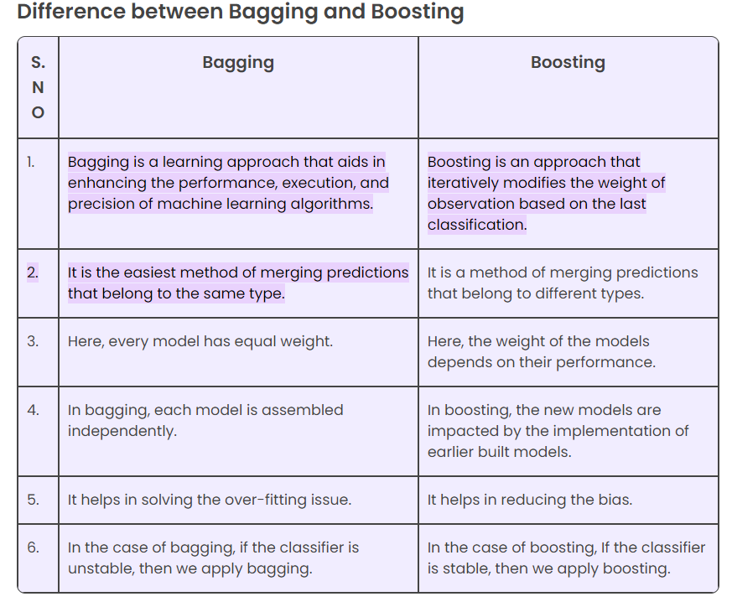

1. What is out-of-bag error in random forests?

ANSWER:

**Out-of-bag** (**OOB**) **error**, also called **out-of-bag estimate**, is a method of measuring the [prediction error](https://en.wikipedia.org/wiki/Prediction_error) of [random forests](https://en.wikipedia.org/wiki/Random_forest), [boosted decision trees](https://en.wikipedia.org/wiki/Gradient_boosting), and other [machine learning](https://en.wikipedia.org/wiki/Machine_learning) models utilizing [bootstrap aggregating](https://en.wikipedia.org/wiki/Bootstrap_aggregating) (bagging). Bagging uses subsampling with replacement to create training samples for the model to learn from. OOB error is the mean prediction error on each training sample *xi*, using only the trees that did not have *xi* in their bootstrap sample

1. What is K-fold cross-validation?

ANSWER:

Cross-validation is a resampling technique used to validate machine learning models against a limited sample of data. In this article we will talk about K-fold Cross-validation and its advantages and disadvantages.Its working is shown with python program.

The concept of cross-validation is widely used in data science and machine learning. It’s a way to verify the performance of a predictive model before using it in an actual situation. Essentially, it helps you avoid creating inaccurate predictions. Using multiple training sets is crucial when performing cross-validation. You must have multiple test sets to ensure your model performs as expected.In this article we are going to learn about K-fold Cross-validation

1. What is hyper parameter tuning in machine learning and why it is done?

ANSWER:

Hyperparameter tuning, also known as hyperparameter optimization, is a crucial step in machine learning that involves finding the best set of hyperparameters for a model to achieve optimal performance. Hyperparameters are adjustable parameters that control the model's training process and can't be estimated from training data. They are configured before the model begins learning, and their values can significantly impact the model's performance. For example, in a neural network, hyperparameters might include the number of hidden layers and the number of nodes in each layer. In a linear model, hyperparameters might include the degree of polynomial features to use

.

• **Optimal Performance:** Hyperparameters significantly impact a model's performance. By tuning them, we aim to find the best combination that maximizes accuracy, precision, recall, or other relevant metrics.

• **Prevent Overfitting and Underfitting:** Incorrect hyperparameter values can lead to overfitting (the model performs well on training data but poorly on new data) or underfitting (the model is too simple to capture the underlying patterns).

• **Improve Generalization:** Tuning helps the model generalize better to unseen data, leading to more reliable predictions.

• **Efficiency:** Well-tuned models often require less computational resources and time for training

1. What issues can occur if we have a large learning rate in Gradient Descent?

ANSWER:

if the learning rate is too high, the algorithm may overshoot the minimum, and if it is too low, the algorithm may take too long to converge. Overfitting: Gradient descent can overfit the training data if the model is too complex or the learning rate is too high.

**. Overshooting the Minimum**

* **Oscillation:** The algorithm might overshoot the optimal point and end up on the other side of the error surface.

This can lead to oscillatory behavior, where the model keeps jumping back and forth without converging.

* **Divergence:** In extreme cases, a very large learning rate can cause the algorithm to diverge completely, meaning the error increases instead of decreasing.

**2. Missing Local Minima**

* **Jumping Over Minima:** A large learning rate can cause the algorithm to skip over local minima, potentially preventing the model from finding the best solution.

**3. Instability**

* **Unpredictable Behavior:** With a large learning rate, the model's behavior becomes less predictable, making it difficult to control the training process.

**4. Slow Convergence**

* **Inefficient Updates:** While it might seem counterintuitive, a very large learning rate can sometimes lead to slow convergence. This is because the algorithm might be taking such large steps that it spends a lot of time exploring areas of the parameter space that are far from the optimal solution

1. Can we use Logistic Regression for classification of Non-Linear Data? If not, why?

ANSWER:

Logistic regression is simple and easy to implement, but it also has some drawbacks. One of them is that it assumes a linear relationship between the input features and the output. This means that it cannot capture the complexity and non-linearity of the data.

**No, logistic regression is not well-suited for classifying non-linear data.**

**Why?**

* **Linear Decision Boundary:** Logistic regression essentially fits a linear decision boundary between classes.

This means it's best suited for datasets where the classes can be separated by a straight line.

* **Incapability to Capture Complex Patterns:** When dealing with data points that exhibit complex, non-linear relationships, logistic regression will struggle to accurately classify them.

**Visual Example:**

**linearly separable dataset vs. a nonlinearly separable dataset**

**Potential Solutions:**

If you encounter non-linearly separable data, consider using algorithms designed to handle such patterns:

* **Support Vector Machines (SVMs):** Can handle complex decision boundaries through the use of kernels.
* **Decision Trees:** Can capture non-linear relationships effectively.
* **Neural Networks:** Highly flexible models capable of learning complex patterns.

By understanding the limitations of logistic regression and exploring alternative models, you can improve the performance of your classification tasks

1. Differentiate between Adaboost and Gradient Boosting.

ANSWER:

**Adaboost vs. Gradient Boosting**

Both Adaboost and Gradient Boosting are ensemble techniques that combine multiple weak learners to create a strong predictive model.

However, they differ in their approach to building the ensemble.

**Adaboost**

* **Focuses on errors:** Assigns higher weights to misclassified instances in each iteration.
* **Weak learners:** Typically decision stumps (decision trees with only one split).
* **Additive model:** Combines weak learners with weights based on their performance.
* **Loss function:** Specific loss function for classification problems.

**Gradient Boosting**

* **Focuses on residuals:** Fits new models to the residuals of the previous model.
* **Additive model:** Combines weak learners with weights determined by gradient descent.
* **Loss function:** More flexible, can handle different loss functions for regression and classification.

**Key Differences**

|  |  |  |
| --- | --- | --- |
| **Feature** | **Adaboost** | **Gradient Boosting** |
| Focus | Misclassified instances | Residuals |
| Weak learners | Typically decision stumps | Can be various models |
| Weighting | Based on performance | Determined by gradient descent |
| Loss function | Specific for classification | Flexible, can handle different loss functions |

Export to Sheets

**In summary:**

* Adaboost focuses on improving the performance of misclassified instances by adjusting their weights.
* Gradient Boosting aims to minimize the overall loss function by fitting new models to the residuals of previous models.

Gradient Boosting is generally considered more flexible and powerful than Adaboost, as it can handle different loss functions and is less sensitive to noise in the data. However, Adaboost is still a valuable technique in certain cases.

1. What is bias-variance trade off in machine learning?

ANSWER:

**Bias-Variance Trade-off**

The bias-variance trade-off is a fundamental concept in machine learning that addresses the challenge of building models that generalize well to unseen data.

**Bias**

* **Definition:** The difference between the average prediction of a model and the correct value.
* **High bias:** A model that is too simple, underfitting the data, leading to inaccurate predictions.

**Variance**

* **Definition:** The variability of model predictions for different training sets.
* **High variance:** A model that is too complex, overfitting the data, leading to poor performance on new data.

**The Trade-off**

* **Balancing Act:** There's an inherent trade-off between bias and variance.
* **Underfitting:** High bias, low variance (simple model)
* **Overfitting:** Low bias, high variance (complex model)
* **Optimal Model:** The goal is to find a balance between the two, resulting in a model that generalizes well to new data.

**In essence,** the challenge lies in building a model that is complex enough to capture the underlying patterns in the data but not so complex that it memorizes the noise

1. Give short description each of Linear, RBF, Polynomial kernels used in SVM.

ANSWER:

**Kernels in SVM**

Kernels are used in Support Vector Machines (SVMs) to transform data into a higher-dimensional space, allowing for the creation of non-linear decision boundaries.

**Linear Kernel**

* **Simplest kernel:** Calculates the dot product between two data points.
* **Suitable for:** Linearly separable data.
* **Equation:** K(x, y) = x * y

**Polynomial Kernel**

* **Introduces non-linearity:** Maps data into a higher-dimensional space using polynomial functions.
* **Suitable for:** Data with polynomial relationships.
* **Equation:** K(x, y) = (γ * x * y + r)^d (where γ, r, and d are parameters)

**RBF (Radial Basis Function) Kernel**

* **Most commonly used:** Maps data into an infinite-dimensional space.
* **Effective for:** Non-linear relationships and complex data.
* **Equation:** K(x, y) = exp(-γ * ||x - y||^2) (where γ is a parameter)

